Software Design Document

<Project Name>

Student Names

Table of Contents

1.0 System Vision 3

1.1 Problem Background 3

1.2 System Overview 3

1.3 Potential Benefits 3

2.0 Requirements 4

2.1 User Requirements 4

2.2 Software Requirements 4

2.3 Use Cases 4

3.0 System Components and Software Design 5

3.1 System Components 5

3.2 Software Design 5

4.0 User Interface Design 6

# System Vision

## Problem Background

The Victoria State Accident Dataset Contains a wealth of information related to accidents that occurred over a five-year period from 2015 to 2020. This dataset provides a comprehensive record of road crash statistics, enabling in-dept analysis of road safety incidents. Even though, a large amount of data is available, effectively extracting insights and trends from this dataset poses significant challenges. Without a dedicated tool, the process of visualising the data and gaining actionable insights becomes even more toiling. This can hinder the ability of researchers or the policymakers to make informed decisions based on accurate accident analysis. Moreover, manually sifting through vast amounts of data to analyse accident patterns, identify contributing factors and predict accident outcomes is a time consuming and complex task. Thus, to address these challenges, our project aims to develop a user-friendly efficient data analysis and visualization tool specifically tailored to the Victoria State Accident dataset.

## System Overview

The envisioned data analysis and visualization tool for the Victoria State Accident Dataset will offer an intuitive and user-friendly interface that empowers users to interact seamlessly with the complex accident data. The system will integrate advanced data processing and visualization techniques to provide users with clear understanding of accident trends and contributing factors. The system will allow the users to select specific time frames to analyse accident data with the desired periods. The system will display detailed information about the accidents including accident date, time, type, and all other information related to the accidents. Users will be able to visualise the average number of accidents per hour throughout the day, aiding in identifying high-risk hours. The system will enable users to search for accidents bases on accident types containing specific keywords. Users can analyse the impact of alcohol and potential correlations. The system will provide one additional analysis/visualization/insight, enhancing the tool’s analytical capabilities.

## Potential Benefits

The envisioned data analysis and visualization tool for the Vitoria State Accident Dataset offer numerous potential benefits across various domains. By providing a user-friendly interface that enables users to interact with the dataset in a meaningful way, the software aims to facilitate a deeper understanding of accidents trends and contributing factors. Some potential benefits of the software include:

* The tools will enable users to quickly explore the dataset, filter relevant information and visualize accident data using charts and graphs.
* Through advanced data analysis techniques, the tool can uncover hidden patterns, correlations, and trends within the dataset, offering users valuable insights into road safety.
* Policymakers, researchers, and analysts can make evidence-based decisions for road safety improvements, resource allocation and accident prevention strategies.
* The software can potentially offer predictive capabilities, allowing users to anticipate accident hotspots, risk factors and patterns that might lead to accidents re-openings.
* By automating data analysis tasks and offering visualizations, the tools reduce the time and effort required for manual data interpretation.
* Ultimately, the software’s insights and recommendations could contribute to more effective road safety initiatives, leading to a reduction in accidents and then associated impacts.

# Requirements

## User Requirements

In this section, we describe how individual interact with the software from an end-user perspective. It sheds light on various tasks users should be able to perform and the capabilities they require from the software. For our project, we will envision a hypothetical user profile to guide the user requirements definition.

### 2.1.1 User interaction

#### User Profile:

Name: Anna Johnson

Role: Traffic safety Officer

Background: Holds a degree in urban planning and has been working with the local transportation department. Anna’s responsibilities include analysing accident data to identify road safety issues and propose improvement strategies.

User Requirements for the Data Analysis and Visualization Tool:

1. Import and Load Data:

The user needs to be able to import the Victoria State Accident Dataset into the tool.

The software should automatically validate and process the dataset for accurate analysis.

1. Dashboard Overview:

Upon logging in, Anna needs to be presented with a dashboard that provides an overview of recent accident trends and key statistics.

1. Custom time selection:

The user should be able to specify a time frame for analysis, such as a particular month or year.

1. Filtering parameters:

She should be able to filter accident data based on factors such as weather conditions, time of the day, road types, vehicle types, and accident severity. Anna should be able to enter a keyword related to accident types (for example: “collision”, “pedestrian” to retrieve accidents of interest.)

1. View Accident Details:

She should be able to see the detailed information about the accident including date, time, accident type, location, the collision type, the type of vehicle and other data involved in the accident.

The information should be presented in an organised and easily accessible manner.

1. Analyse hourly trends:

The user needs to be able to generate a chart displaying the average number of accidents in each hour of the day within the selected period. She wants to view a time series plot that shows how accident frequencies have changes over the selected period.

1. Comparative analysis:

Anna needs the ability to compare accident data based on different factors, such as urban, vs rural or licensed or unlicensed.

1. Alcohol Impact Analysis:

Amma needs to be able to analyse the impact of alcohol consumption in accidents by exploring trends and accident types involving alcohol.

1. Interactive maps:

She needs to interact with maps that display accident locations, and hotspots in the chosen region and time frame. She should be able to zoom in and click on markers to view accident details.

1. Safety Recommendations:

Amma needs to get safety recommendations and preventative measures for different scenarios based on the analysis.

1. Customization and Export:

She should be able to customise the visualizations and reports by selecting specific filters and parameters. She also needs the ability to export the analysis results.

#### User interaction: -

1. Anna logs into the tools and is greeted with the dashboard overview.
2. She selects the state and time frame for analysis.
3. She applies filters based on her research interests, such as location and road types.
4. She interacts with the map to explore accident locations.
5. She switches to the time series plot to analyse trends.
6. Anna compares accident data across different factors and views predicted accident occurrences.
7. She reviews safety recommendations provided by the tool.
8. Anna views the maps and make an analysis report and exports her report.

**Assignment note: In this section you detail how a user is supposed to interact with or use you program. What do they need to be able to do? This should all be from the end users perspectives. Can be a combination text and listing of needs. You have not been given a client/user, so you can make one up. Who do you think would be using your software?**

## Software Requirements

**R1. Data Selection and Filtering:**

* R1.1: The tool shall allow users to select a specific location for analysis.
* R1.2: Users shall be able to specify the time period for the analysis.
* R1.3: User shall be able to apply filters for weather conditions, road types, vehicle types, and accident severity.

**R2. Interactive Mapping:**

* R2.1: The tool shall provide interactive maps displaying accident locations, hotspots, clusters with the chosen location and time frame.
* R2.2: Users shall be able to zoom in and out of the maps for detailed analysis.
* R2.3: Users shall have the option to click on accident markers to view detailed information about each accident.

**R3. Time series visualization:**

* R3.1: The tools shall be able to produce the charts based on the average number of accidents that happen over the selected period.
* R3.2: Users should be able to adjust the time granularity for the time series plot.

**R4. Comparative analysis:**

* R4.1: The tool shall enable users to compare accident data across different factors, such as, urban vs rural areas, time of the day, weekday, or weekend, licensed or unlicensed.
* R4.2: Users will be able to analyse the affect of alcohol time on rate of accidents on daily basis.

**R5. Safety Recommendations:**

* R5.1: The tool shall be able to generate safety recommendations for improving road safety based on the analysis results.

**R6. Customisation and export:**

* R6.1: The users shall be able to customise the visualisations by adjusting filters and parameters within each section.
* R6.2: The tool shall provide options to export visualisations and analysis results in various formats, such as PDF and CSV.

**R7. User friendly interface:**

* R7.1: The tool’s interface shall be intuitive and easy to use and navigate providing a seamless user experience.

In this section you detail what the requirements for the software are. What functionality will it provide? This is usually a formal listing, with requirements often using the word ‘Shall’. IE:

R1.1 The program shall accept multiple file names as arguments from the command line.

R1.2 Each file name can be a simple file name or include the full path of the file with one or more levels.

etc …

Can be primarily functional requirements, though you may include other types if you think of them.

## Use Cases & Use Case Diagrams

**Use Case1: Display Accident Information:**

* Actor: Traffic Safety Analyst
* Description: This use case outlines how the user can view detailed information about all accidents that occurred within a user-selected period.
* Steps:

1. User logs into the Accident Analysis Tool
2. User selects the location and time period for analysis.
3. User navigates to the "Accident Information" section.
4. System retrieves and displays a list of accidents that occurred within the selected time period.
5. User can click on an accident entry to view more detailed information about that accident.

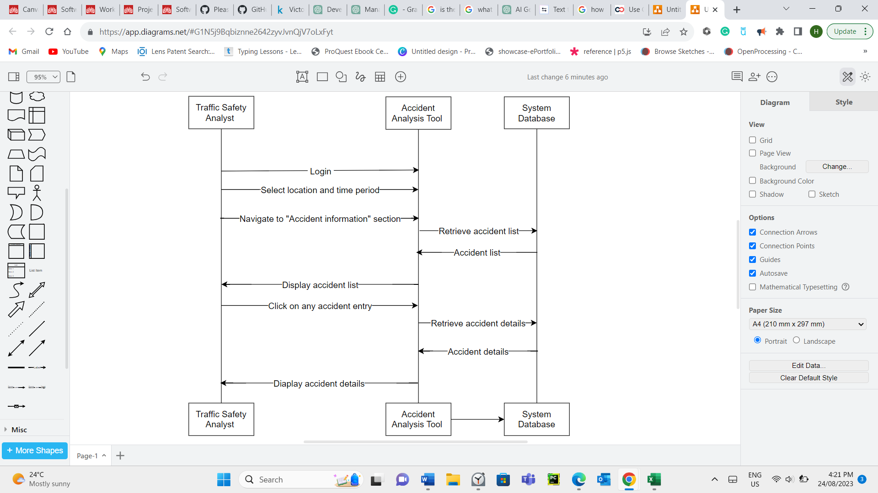

**User Case 2: Time based Accident Frequency Chart:**

* Actor: Road safety officer:
* Description: The user analyses accident trends over a specific time period
* Steps:

1. User logs in and selects the location for analysis.
2. User specifies the time period.
3. User clicks on the “Time Trends” option.
4. System generates a time series plot displaying accident frequencies.
5. System calculates and generates a chart that displays the average number of accidents in each hour of the day over the selected period.
6. User can adjust time granularity for closer analysis.
7. User interprets the chart to identify patterns and trends in accident occurrences throughout the day.

**User Case 3: Alcohol Impact analysis:**

* Actor: Road Safety Manager
* Description: The user compares the accidents that happen when people do drunk driving with those without alcohol consumption.
* Steps:

1. User selects the location and time.
2. User applies filters to focus on alcohol Time.
3. User clicks on the “Comparative Analysis” option.
4. System presents a comparison of accident data for the specified factors.

Trend analysis showing changes in alcohol-related accidents over time.

Visualisation of accident types frequently involving alcohol.

1. User interprets the visualizations to identify correlations and patterns related to alcohol-related accidents.

**User case 4: Generate Safety Recommendations:**

* Actor: Transportation Planner
* Description: The user generates safety recommendations based on analysis results.
* Steps:

1. User specifies the location, time period.
2. User selects the relevant filters like, road type, speed limit.
3. System process analysis data and generates safety recommendations.
4. User reviews and exports the recommendations for the reports.

**User Case 5: Search by Accident Type keyword:**

* Actor: Researchers and Analysts:
* Description: This use case demonstrates how the user can retrieve all the accidents caused by an accident type that contains a user-entered keyword.
* Steps:

1. User logs into the Accident Analysis Tool.
2. User selects the desired location and time period.
3. User enters the keywords like, collision, pedestrian, daylight, urban, public transport, etc.
4. User initiates the search in the “Accident Type Analysis” section.
5. System retrieves and displays a list of accidents that match the entered keyword in their accident type description.

In this section you provide some use cases showing how people may use your software.

# Software Design and System Components

## Software Design

A block diagram/flowchart of how your software might work

## System Components

### Functions

Preliminary list of all functions in the software. For each function in the list the following information is provided:

* a brief description of what it does (1 or 2 sentences);
* a list of the input parameters, and their data types, and what they are used for;
* a list of any side effects caused by the function (i.e. change global or member variables, changes data passed by reference from calling function etc)
* a description of the function’s return value

### Data Structures / Data Sources

List of all data structures in the software (e.g. linked lists, trees, arrays etc) or eternal data sources. For each data structure in the list the following information is provided:

* Type of structure (tree, list etc),
* Description of where and how it is used
* List of data members, and what each one is for do
* List of functions that use it

### Detailed Design

Pseudocode for all non-standard / non-trivial algorithms that operate on data structures

# User Interface Design

This is your initial interface design. Describe the tools you used for this design stage and any key findings that informed your design. This introduction is descriptive and should explain what you have completed for the actual design work you will present in the sub-sections below.

## Structural Design

Structural design refers to the navigational and information structure of your product – the structure that supports the interface layout. How will you structure your product? How will you group your information? How will you navigate through your product? Why? This can take the form of a diagram showing structure and hierarchy, supported by a discussion and justification of your choices. Why have you made these design choices? Describe and outline the structure of your interface and of your information.

## Visual Design

Detail your visual design: Layout, visual elements, icons, graphics, style, colour, fonts general screen designs. This can be sketches, wireframes, mock-ups etc, supported by a discussion, explanation, and justification of your choices.